**Download and install Matlab Compiler Runtime (MCR)**

* This is a freely available program you can download from the Matlab website:
* *http://nl.mathworks.com/products/compiler/mcr/*
* MCR allows users without a full version of Matlab to execute programs that have been precompiled for them. The only limitation with MCR is that you cannot view or modify any Matlab scripts.

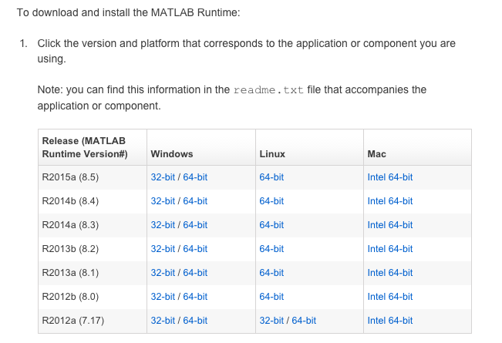

* You must download the version of MCR that corresponds to the version which was used to compiled the script you want to run. In this case, we compiled the program on **version** **2013a 32-bit** so you will download that version.
* After downloading, install MCR. Once installed, the MCR is saved in your System32 folder, so you will not be able to see it listed in your **Programs** list.

**Running particle motion analysis with MCR**

1. Double click the PM_Analysis_Windows.exe file which was provided to you

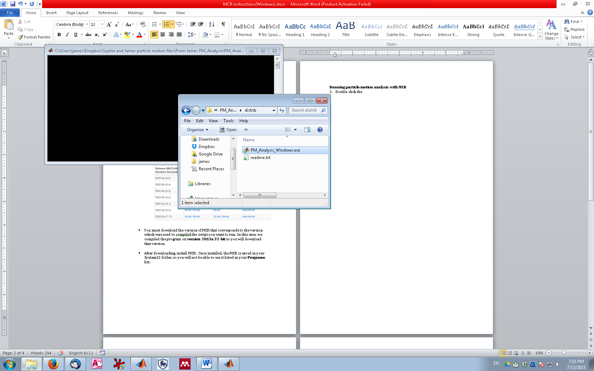

1. The program will launch and your output will be displayed in the **cmd** screen.

